**Lagman (Uzbek Noodle Soup)**

Tasty, easy noodle soup. Great Uzbek (Central Asian) dish. Garnish with fresh parsley or dill.

By [dilyadavid](https://www.allrecipes.com/cook/3031195/)

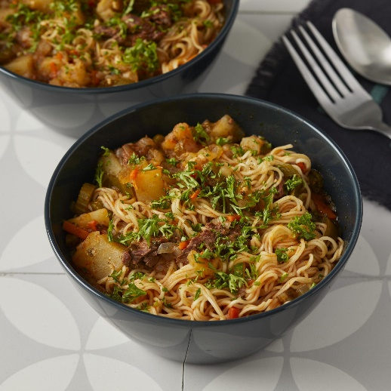

Ingredients

2 tablespoons olive oil

1 onion, finely chopped

½ pound beef chuck, cut into strips

1 teaspoon ground cumin

½ teaspoon ground black pepper

2 tablespoons tomato paste

1 carrot, cut into thin strips

1 green bell pepper, cut into 1-inch strips

3 small potatoes, cubed

½ cup thinly sliced celery

8 cups water

2 teaspoons salt

½ cup finely chopped parsley

3 large cloves garlic, minced

2 (8 ounce) packages thin Chinese noodles

Directions

1. Heat oil in a large pot over high heat. Reduce heat to medium-high; cook and stir onion in the hot oil until golden, 3 to 5 minutes. Stir in beef strips, cumin, and black pepper; cook until beef is browned, about 5 minutes. Stir in tomato paste and cook for 2 to 3 minutes.

2. Stir carrot into the pot; cook until coated with tomato paste, 2 to 3 minutes. Add green bell pepper; cook for 1 minute. Add potatoes and celery; cook for 5 minutes. Pour in water; bring to a boil. Season water with salt. Reduce heat to low and simmer soup until potatoes are soft, about 40 minutes.

3. Stir parsley and garlic into the soup. Simmer until garlic is soft, 10 to 15 minutes.

4. Bring a large pot of lightly salted water to a boil. Cook noodles in the boiling water, stirring occasionally, until tender yet firm to the bite, 3 to 5 minutes. Rinse and drain well. Divide among serving bowls. Ladle hot soup over noodles.

https://www.allrecipes.com/recipe/257857/lagman-uzbek-noodle-soup/

Note: Instead of 8 cups of water, you can use broth.